**color**

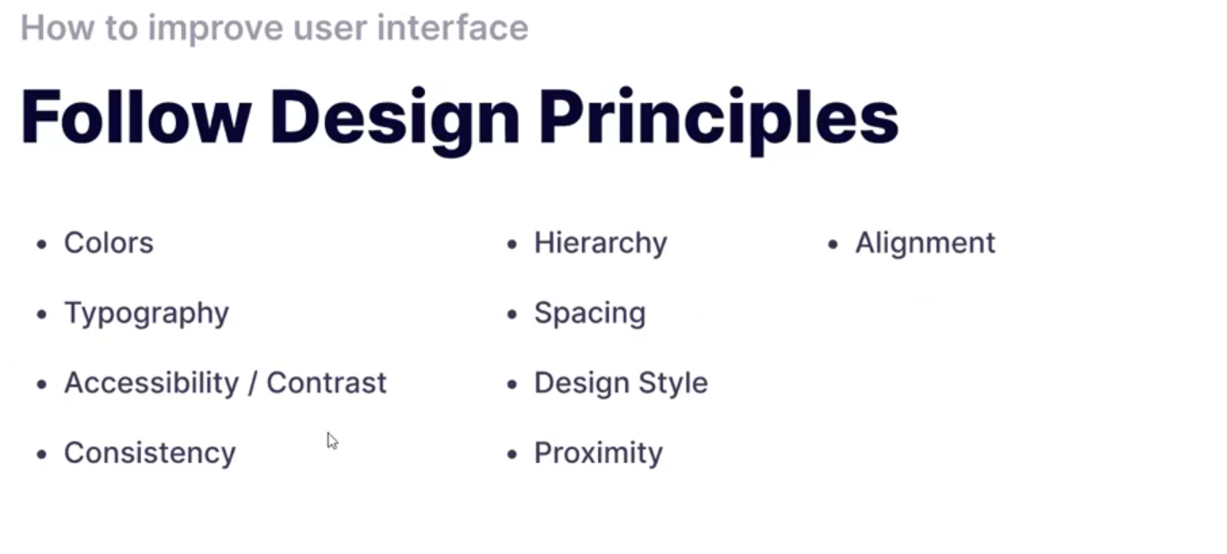**Rule of design-> when a visitor visit a website the website must be design like the way that the visitor or the user can understands the website within 15s to 16s**

* **There is only a primary color work website**

**Always try to work with one main color ,you can use two color but not more than**

**Website for test in color :** **[Realtime Colors](https://www.realtimecolors.com/?colors=050315-fbfbfe-2f27ce-dedcff-433bff&fonts=Inter-Inter)**

**Website for unlimited color:** <https://coolors.co/>

**Typography**

**Best use the one font**

**Website for this ->** [**https://typescale.com/**](https://typescale.com/)

**Accessibility/Contrast**

**Color Contrast checker :** [**https://coolors.co/contrast-checker/112a46-4f87c4**](https://coolors.co/contrast-checker/112a46-4f87c4)

**Icons**

**Website->**[**https://tabler.io/icons**](https://tabler.io/icons)

